# MySQL Assignment Part 1

Query 1 SELECT

This query selected all customers from the sql_store database.

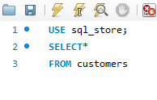

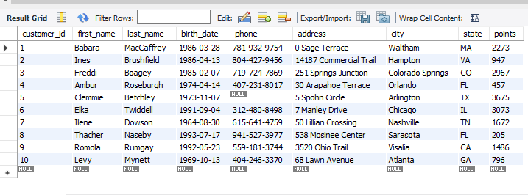

Query 1 continued

This query selects all columns from the customers table where customer_ID is equal to 1 and order the results by first_name.

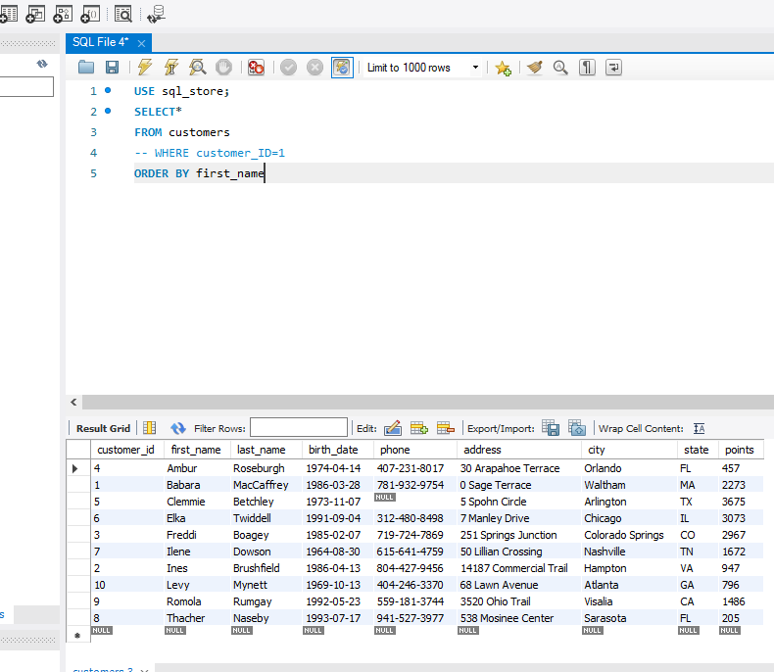

Query 2 SELECT

This query will select the first name, last name, points from the customers table, does a calculation – adding points by 10, in a new column.

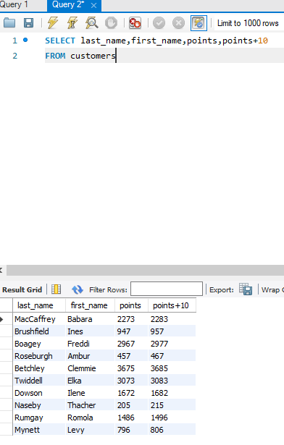

Task 1

1. 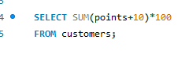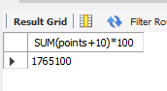
2. In this query, a calculation is made from the points column and by using the AS function will rename the column.

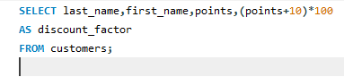 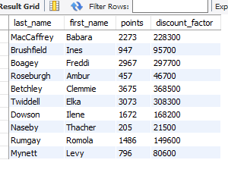

Task 2

To add a new column that shows a 10% price increase for all products, I will select name, unit_price and will do a calculation – unit price*1.1. To name the new column, I will use the AS function and name it as new_price. This query will return all products from the database. Now we can see the name, unit price and new price.

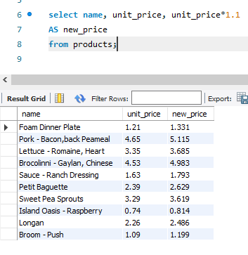

Task 3

For this task, I will create a new query to find all the customers with a birth date of > ‘1990-01-01'. I used the ‘WHERE’ clause and the query will find all customers whose birthday is after 01-01-1990. The result shows three customers.

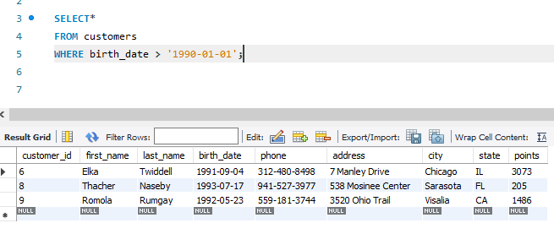

Task 4

To find out the name of the product with the most amount in stock I will write the select all from sql_inventory from products. Then use order by function to order the quantity in stock by ‘desc’ and this shows that sweet pea sprouts are the product with the most amount of stock.

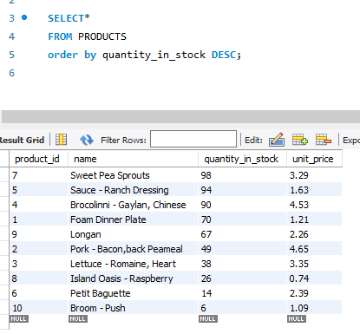

Task 5

To find out the name of the most expensive product, I repeated the previous query I made but changed the order by to unit price. This query shows the products pork –bacon, back peameal is the most expensive price.

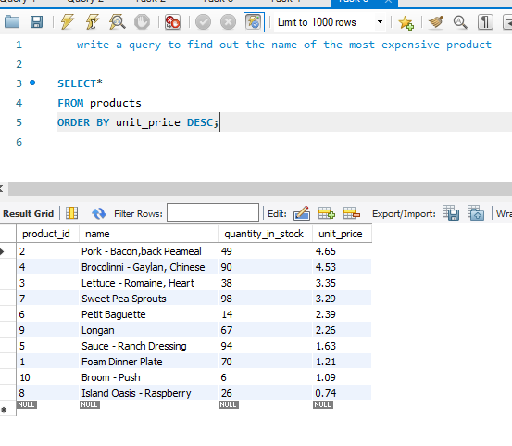

Task 6

For this task, I need to find out the first name, last name, address and the birthdate of the oldest customer. I used the ‘MIN’ function to find out the oldest birthdate of a customer. Where clause will return all birthdate that is equal to the minimum birthdate in the customer's table. The results show that Ilene is the oldest customer.

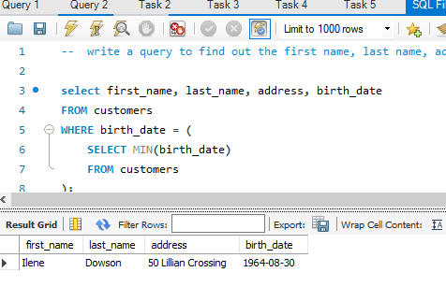

ER Diagram

ERDs provide engineers with a visual way to understand how data in a database is related and how it works together. Relationships describe how these entities interact with each other and this is shown with cardinality which helps define the relationship.

A primary key is an attribute or field that uniquely identifies every record within a certain table. A foreign key is an attribute in one entity that links to the primary key of another entity. Consequently, they enable relationships between those entities.

For example, in this ER diagram, the first row is the table name, the second row is the primary keys and the rest are the attributes. Customers are linked to their orders and payments. Each customer is identified by a unique CustomerNumber. They also have a SalesRepEmployeeNumber attribute indicating the employee responsible for that customer. Each order is placed by a specific customer indicating by the CustomerNumber. Each order has unique OrderNumber and contains multiple OrderDetails. The relationship between the CustomerNumber and order is that they can have only one customer number to order with. For Customers to Orders, a customer can place multiple order, so this cardinality is one to many. This is a similar relationship between Payments and OrderDetails.

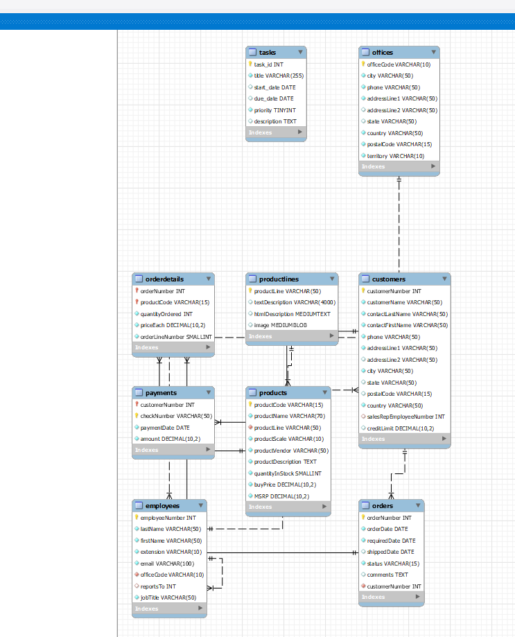

# MySQL Assignment Part 2

Task 1

This query will count the number of rows where the country code is 'USA' within the city table. These results show that there are 274 cities in the USA.

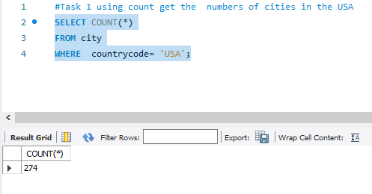

Task 2

I used the function SUM to find the total population and AVG to find the average life expectancy found in the column’s ‘country’ and used WHERE so that the query returns only countries from Argentina.

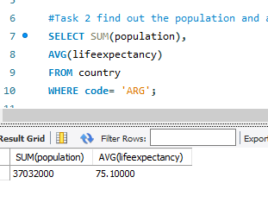

Task 3

This query will select the name and life expectancy columns from the country table. I used ORDER BY to order the results by life expectancy in descending order and LIMIT the output to only one row. The result shows country with the highest life expectancy in the table is Andorra.

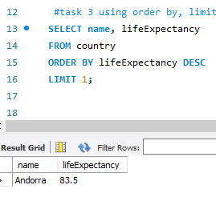

Task 4

Using the function LIKE will return all country names starting with an ‘f’ and using the LIMIT function again will limit the output to only 25 rows.

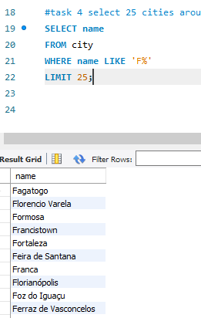

Creating SQL statements

Task 5

For this task, I need to create a SQL statement to display columns ID, name, population from the city table and limit results to first 10 rows only. I selected what columns I need from the city table and then used the limit function, and the query will return 10 cities. 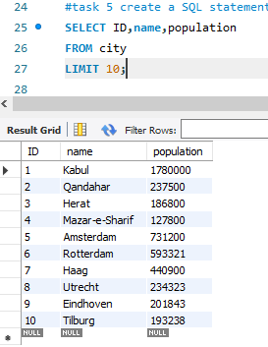

Task 6

This query selects the name of the cities and using the WHERE condition will find the population greater than 2000000 and 92 rows were returned.

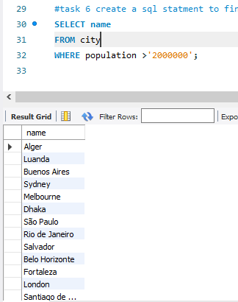

Task 7

To find out all city names that begin with “Be”, I will use LIKE function.

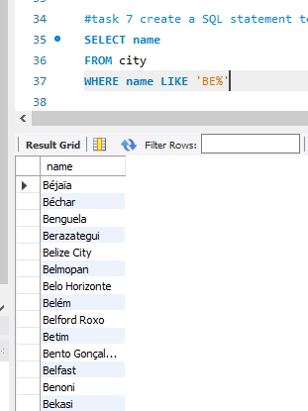

Task 8

To find out cities whose population is between 500000-100000, I will use the between function and use where clause so that the query filters rows based on the range of values. This query will return the name and population of all cities whose population is between the values I put it.

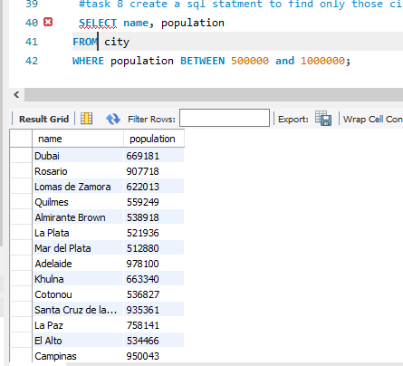

Task 9

To find out what city has the lowest population, I selected the names for the cities and population which are found in the columns under the city table. I used order by and asc for the results to show in lowest to highest population in cities and used limit for the output to show one row.

